FNB BANK; FONTANELLE, IA
2. Print Outs
Cover Page
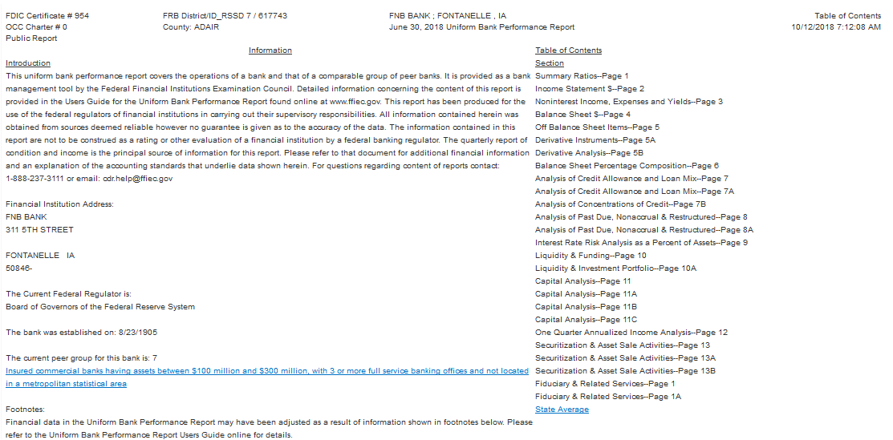

Summary Ratios Page
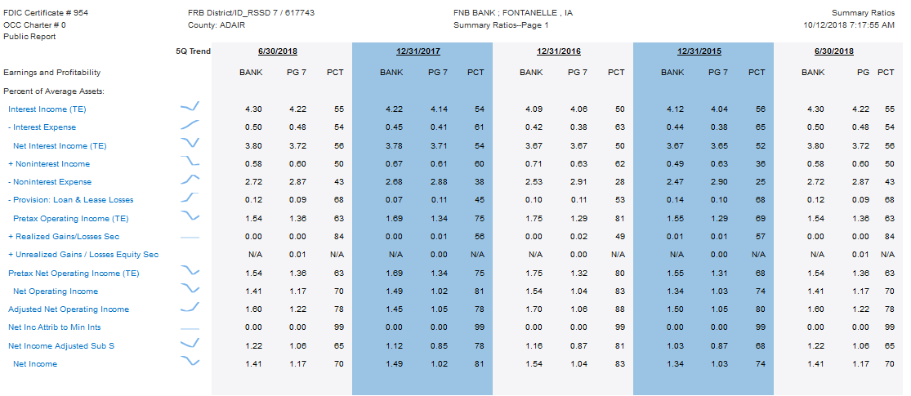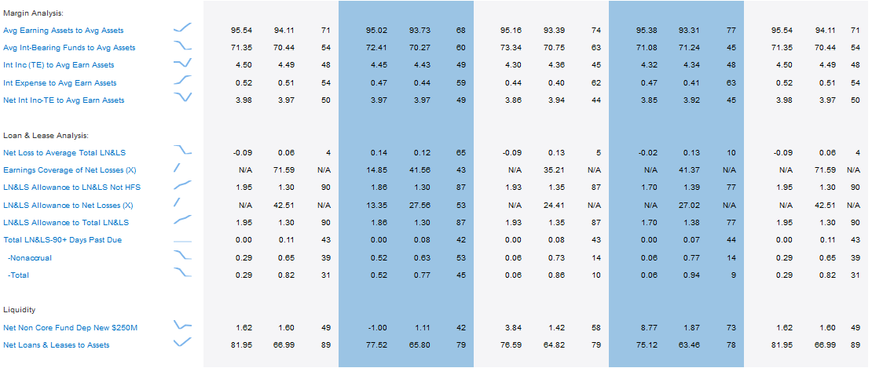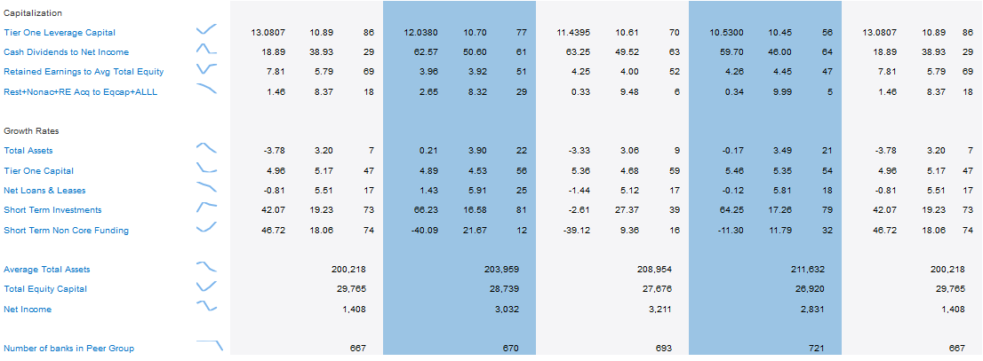
Income Statement Page
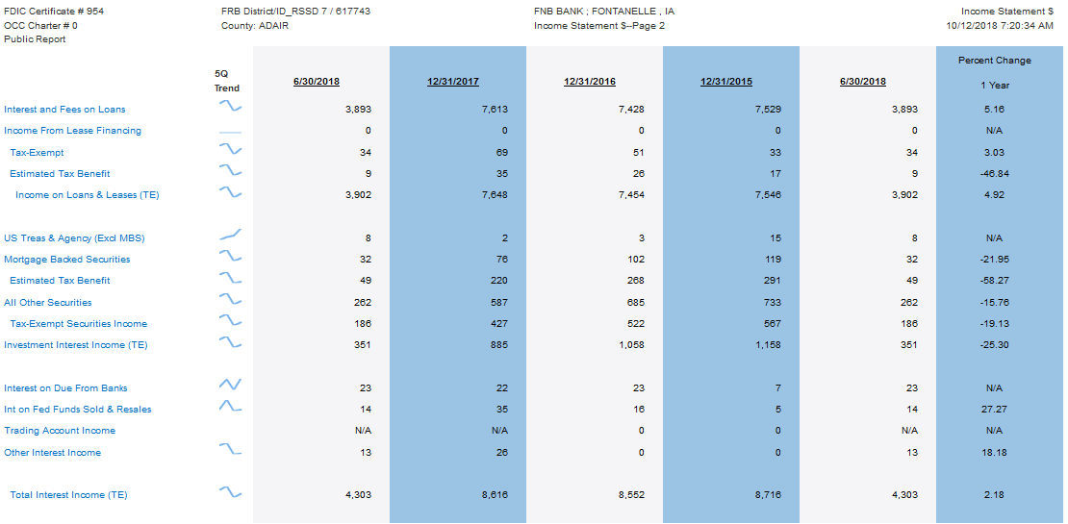
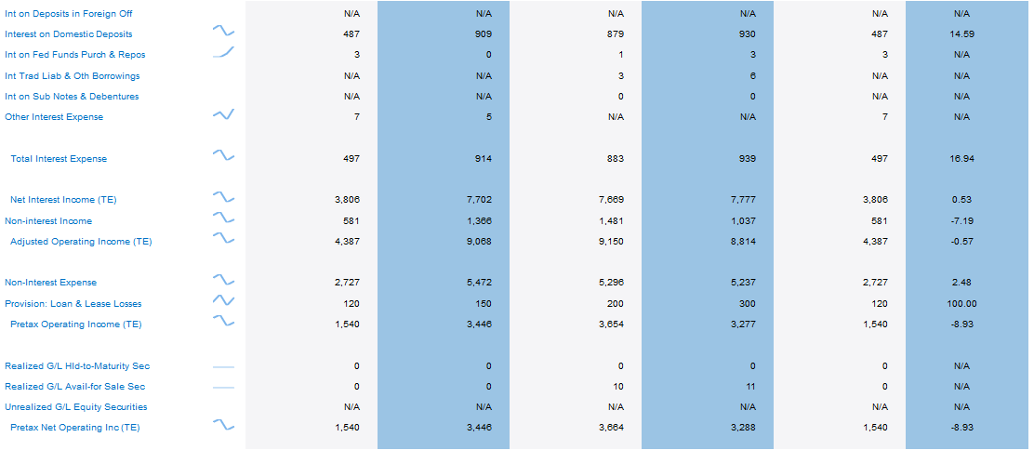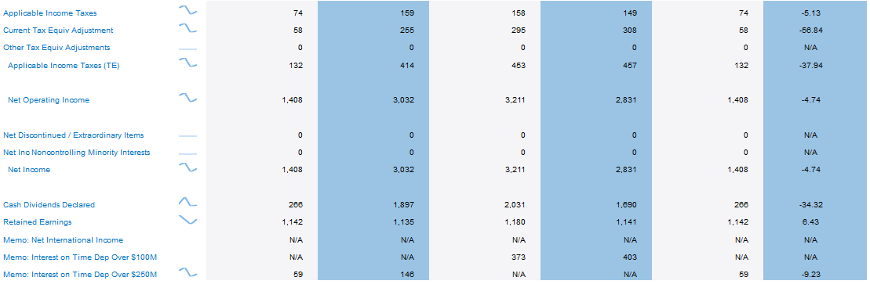
Source: (FNB Bank; Fontanelle, IA - Uniform Performance Report, 2018)
3. FNB Bank Information from Summary Tables
FNB BANK (% Total Assets) | 31/12/2015 | 31/12/2016 | 31/12/2017 | 30/06/2018
Net Interest Income | 3.67 | 3.67 | 3.78 | 3.8
Non-Interest Expense | 2.47 | 2.53 | 2.68 | 2.72
Less Non-Interest Income | 0.49 | 0.71 | 0.67 | 0.58
Burden | 1.98 | 1.82 | 2.01 | 2.14
Provision: Loan & Lease Losses | 0.14 | 0.1 | 0.07 | 0.12

4. FNB Bank
FNB BANK (Percentile Rank) | 31/12/2015 | 31/12/2016 | 31/12/2017 | 30/06/2018
Net Interest Income | 52 | 50 | 54 | 56
Non-Interest Expense | 25 | 28 | 38 | 43
Less Non-Interest Income | 36 | 62 | 60 | 50
Burden | -11 | -34 | -22 | -7
Provision: Loan & Lease Losses | 68 | 53 | 45 | 68

5. Comments
There are no unusual variations in these trends. The trends are all within a small range with gradual improvement over the years.

Reference
FNB Bank; Fontanelle, IA - Uniform Performance Report. (2018). Retrieved from Federal Deposit Insurance Corporation: https://cdr.ffiec.gov/public/Reports/UbprReport.aspx?rptCycleIds=110%2c107%2c101%2c86%2c&rptid=283&idrssd=617743&peerGroupType=&supplemental=

